MATLAB Assignment # 7

By: Jonathan Lopez

ECE 2010

Section B03; Mailbox # 207


Due 12/8 @ 9PM

MATLAB PROBLEM 7 ECE2010 B19

Introduction to MATLAB Toolboxes

Due Date – Sunday Dec 8th by 9PM

Preamble

What is a MATLAB toolbox? Briefly speaking, this is a set of functions and algorithms intended and developed to solve a certain specialized task: such as machine learning, statistics, pattern recognition, image segmentation, image processing, radio-frequency circuit analysis, antenna analysis, etc.

The toolboxes are distributed along with MATLAB, but a commercial user has to pay separately for each of them. WPI and other academic entities have purchased virtually every MATLAB toolbox.

In our seventh MATLAB assignment, we will
- Find out what toolboxes are available as of the end of 2018.
- Find out what MATLAB Antenna Toolbox™ is for, and what basic tasks you can do with it. This toolbox is chosen because it was designed and launched in 2015 by two former WPI graduates (and one former MIT graduate). All three are now employees of MathWorks, Inc., creator of MATLAB.

1. Finding the toolboxes that are available

There is a command, ver, in MATLAB that allows you to see the current version, all the toolboxes installed and which versions are installed. Type this into the command line in MATLAB to see all toolboxes that are installed.

Your Task #1:
- Find out what version of MATLAB are you using.
- Find out how many toolboxes are installed.
- List three toolboxes that potentially may be interesting to you personally from the viewpoint of future research. After that, clear the command window using the clc command.
1.


2.
Simulink Version 9.3 (R2019a)
5G Toolbox Version 1.1 (R2019a)
AUTOSAR Blockset Version 2.0 (R2019a)
Aerospace Blockset Version 4.1 (R2019a)
Aerospace Toolbox Version 3.1 (R2019a)
Antenna Toolbox Version 4.0 (R2019a)
Audio Toolbox Version 2.0 (R2019a)
Automated Driving Toolbox Version 2.0 (R2019a)
Bioinformatics Toolbox Version 4.12 (R2019a)
Communications Toolbox Version 7.1 (R2019a)
Computer Vision Toolbox Version 9.0 (R2019a)
Control System Toolbox Version 10.6 (R2019a)
Curve Fitting Toolbox Version 3.5.9 (R2019a)
DSP System Toolbox Version 9.8 (R2019a)
Data Acquisition Toolbox Version 4.0 (R2019a)
Database Toolbox Version 9.1 (R2019a)
Datafeed Toolbox Version 5.8.1 (R2019a)
Deep Learning Toolbox Version 12.1 (R2019a)
Econometrics Toolbox Version 5.2 (R2019a)
Embedded Coder Version 7.2 (R2019a)
Filter Design HDL Coder Version 3.1.5 (R2019a)
Financial Instruments Toolbox Version 2.9 (R2019a)
Financial Toolbox Version 5.13 (R2019a)
Fixed-Point Designer Version 6.3 (R2019a)
Fuzzy Logic Toolbox Version 2.5 (R2019a)
GPU Coder Version 1.3 (R2019a)
Global Optimization Toolbox Version 4.1 (R2019a)
HDL Coder Version 3.14 (R2019a)
HDL Verifier Version 5.6 (R2019a)
Image Acquisition Toolbox Version 6.0 (R2019a)
Image Processing Toolbox Version 10.4 (R2019a)
Instrument Control Toolbox Version 4.0 (R2019a)
LTE HDL Toolbox Version 1.3 (R2019a)
LTE Toolbox Version 3.1 (R2019a)
MATLAB Coder Version 4.2 (R2019a)
MATLAB Compiler Version 7.0.1 (R2019a)
MATLAB Compiler SDK Version 6.6.1 (R2019a)
MATLAB Report Generator Version 5.6 (R2019a)
Mapping Toolbox Version 4.8 (R2019a)
Mixed-Signal Blockset Version 1.0 (R2019a)
Model Predictive Control Toolbox Version 6.3 (R2019a)
Model-Based Calibration Toolbox Version 5.6 (R2019a)
OPC Toolbox Version 4.0.7 (R2019a)
Optimization Toolbox Version 8.3 (R2019a)
Parallel Computing Toolbox Version 7.0 (R2019a)
Partial Differential Equation Toolbox Version 3.2 (R2019a)
Phased Array System Toolbox Version 4.1 (R2019a)
Powertrain Blockset Version 1.5 (R2019a)
Predictive Maintenance Toolbox Version 2.0 (R2019a)
RF Blockset Version 7.2 (R2019a)
RF Toolbox Version 3.6 (R2019a)
Reinforcement Learning Toolbox Version 1.0 (R2019a)
Risk Management Toolbox Version 1.5 (R2019a)
Robotics System Toolbox Version 2.2 (R2019a)
Robust Control Toolbox Version 6.6 (R2019a)
Sensor Fusion and Tracking Toolbox Version 1.1 (R2019a)
SerDes Toolbox Version 1.0 (R2019a)
Signal Processing Toolbox Version 8.2 (R2019a)
SimBiology Version 5.8.2 (R2019a)
SimEvents Version 5.6 (R2019a)
Simscape Version 4.6 (R2019a)
Simscape Driveline Version 2.16 (R2019a)
Simscape Electrical Version 7.1 (R2019a)
Simscape Fluids Version 2.6 (R2019a)
Simscape Multibody Version 6.1 (R2019a)
Simulink 3D Animation Version 8.2 (R2019a)
Simulink Check Version 4.3 (R2019a)
Simulink Code Inspector Version 3.4 (R2019a)
Simulink Coder Version 9.1 (R2019a)
Simulink Control Design Version 5.3 (R2019a)
Simulink Coverage Version 4.3 (R2019a)
Simulink Design Optimization Version 3.6 (R2019a)
Simulink Design Verifier Version 4.1 (R2019a)
Simulink Desktop Real-Time Version 5.8 (R2019a)
Simulink PLC Coder Version 3.0 (R2019a)
Simulink Real-Time Version 6.10 (R2019a)
Simulink Report Generator Version 5.6 (R2019a)
Simulink Requirements Version 1.3 (R2019a)
Simulink Test Version 3.0 (R2019a)
SoC Blockset Version 1.0 (R2019a)
Spreadsheet Link Version 3.4.1 (R2019a)
Stateflow Version 10.0 (R2019a)
Statistics and Machine Learning Toolbox Version 11.5 (R2019a)
Symbolic Math Toolbox Version 8.3 (R2019a)
System Composer Version 1.0 (R2019a)
System Identification Toolbox Version 9.10 (R2019a)
Text Analytics Toolbox Version 1.3 (R2019a)
Trading Toolbox Version 3.5.1 (R2019a)
Vehicle Dynamics Blockset Version 1.2 (R2019a)
Vehicle Network Toolbox Version 4.2 (R2019a)
Vision HDL Toolbox Version 1.8 (R2019a)
WLAN Toolbox Version 2.1 (R2019a)
Wavelet Toolbox Version 5.2 (R2019a)

3.
1. Robotics System Toolbox
2. Control System Toolbox
3. Spreadsheet Link

2. Antenna toolbox as an example

To find out what the Antenna toolbox (or any other MATLAB toolbox) does, you can use the help command and then type the first word of the toolbox. For example, to find more about the Antenna toolbox, type

help antenna

You will see A LOT of information. After briefly scanning this list, clear the command window using a command clc.

3. What is an antenna?

In general, an antenna is characterized by its complex impedance, , measured in ohms. The impedance varies with frequency, .The real part of the impedance, , is called the radiation resistance. This is due to the fact that the antenna transfers a circuit’s power into outgoing radiating electromagnetic waves. This is somewhat similar to an electric wire heater with resistance , which also transfers electric power, but into heat. The imaginary part of the antenna impedance, , is called reactance. It is due to distributed capacitance (per unit area) and inductance (per unit length) along metal parts of the antenna. In order to achieve the maximum radiated (or received) antenna power, we always desire

(1)

which is the resonance condition. In reality, the requirement given by Eq. (1) is not easy to fulfill. This equality is only achieved at a certain frequency, which is called antenna’s resonant frequency.

The antenna is modeled and designed by solving Maxwell’s equations numerically in three dimensions. This is a difficult task. Therefore, the corresponding MATLAB Antenna Toolbox has been developed.

4. Blade (or cylindrical) dipole antenna

This is perhaps the most popular antenna type. You will find the resonant (or center) frequency of the center-fed blade dipole with the length of 15 cm and the blade width of 10 mm. A sample script that computes the antenna impedance, , over a frequency band of interest using the Antenna toolbox is given below:

%% Setup analysis parameters
f = linspace(600e6, 1100e6, 256); % frequency in Hz
lA = 0.15; % dipole total length, m
w = 0.010; % width of the blade dipole, m
%% Antenna toolbox model and analysis
d = dipole('Length', lA,'Width', w); % blade dipole model (d is antenna object)
figure; show(d) % visualize antenna geometry
Z = impedance(d, f); % full-wave numerical EM simulation
R = real(Z); % antenna radiation resistance, Ohms
X = imag(Z); % antenna reactance, Ohms

Your Task #2:
- Using the sample script, plot both parts of the dipole antenna impedance
- (R – red, X R – blue) as functions of frequency on the same graph. Properly label the axes and introduce a grid. Hint: to avoid figure overlapping with the dipole geometry figure, you may want to introduce a new figure by using the command
figure;
- Determine frequency at which the resonance condition given by Eq. (1) occurs. This is the resonant frequency:

fres = (show units)___931MHz________________________________________

- On the same graph, plot a vertical line corresponding to the resonant frequency. Hint: use a line command for that purpose.
- Present your final MATLAB figure below.
Dipole antenna impedance as a function of frequency. The resonant frequency is marked by a vertical line.

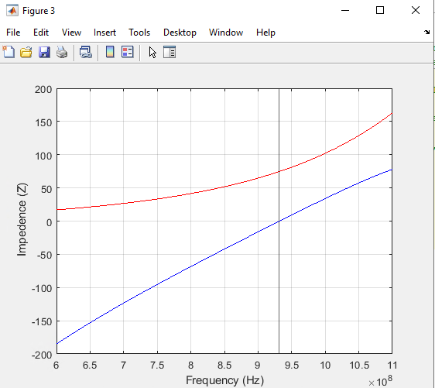

5. In what direction does the antenna radiate?
After antenna’s resonant frequency (or center of the operating frequency band) is found, the next question is to find out in what direction does the antenna radiate? There is no omnidirectional antenna in the nature: every antenna radiates only in certain specific directions. The radiation pattern of an antenna can be found using a command

pattern(d, fres, 'type', 'power');

where d is the antenna (dipole in this case) MATLAB object and fres is the resonant frequency value in Hz found in Task #2. The radiation pattern is simply a 3D polar plot of relative power radiated by the antenna in every direction.

Your Task #3:
- Execute the pattern command given above and obtain the dipole radiation pattern at the resonant frequency. Present your plot below. Hint: to avoid figure overlapping, you may want to close all previous figures.

Antenna radiation pattern.
In which direction(s) does the dipole predominantly radiate? In other words, why do cellular providers like mounting vertical dipoles on cell towers?
They like to radiate out in the X and Y directions but not much in the Z hence why cellular companies have them semi high in the sky.
________________________________________________________________________

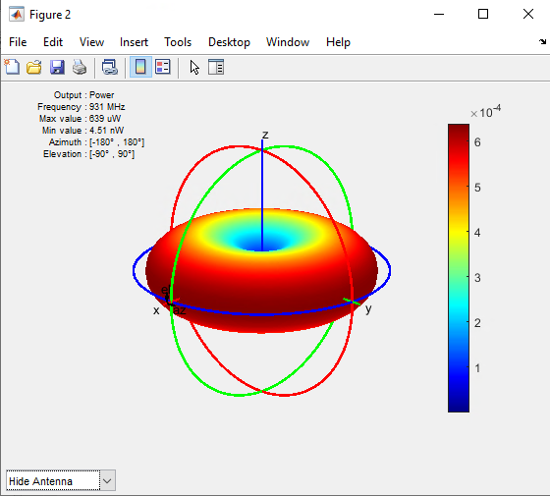

6. Antenna to antenna link. Transmitted and received power. Concept of a transfer function

Now, the major question to ask is the following. Given that the transmitter antenna (TX) radiates, say, 1 W of power, how much of that power could another (receiver) antenna (RX) actually intercept or receive? The answer clearly depends on antenna geometry, frequency, and antenna spacing. MATLAB antenna toolbox allows us to obtain this answer for many different antenna types. The sample script given below computes power received by the RF dipole antenna if the TX dipole antenna radiates exactly 1 W of power and is located 1 m away. This is the power transfer function from one antenna to another.

The answer is somewhat discouraging – in the best possible case, only about 0.2% of input power will be received! The reason is that a small fraction of all radiated waves is intercepted by the receiver antenna. The situation becomes worse when the distance between two antennas increases.

clear;
%% Setup analysis parameters
f = linspace(600e6, 1100e6, 256); % frequency in Hz
lA = 0.15; % dipole total length, m
w = 0.008; % width of the blade dipole, m
antenna_spacing = 1.0; % antenna spacing, m
%% Antenna toolbox model: construct two antennas using array object
d = dipole('Length', lA ,'Width', w); % blade dipole model
l = linearArray('Element', d, 'ElementSpacing', antenna_spacing);
figure; show(l); % visualize geometry for two antennas
S = sparameters(l,f);
S21 = rfparam(S,2,1);
TF = abs(S21).^2; % power transfer function

%% Plot power transfer function
figure; semilogy(f/1e6, TF,'r', 'LineWidth', 2); grid on
title('Ratio of received to transmitted power (power transfer function)')
xlabel('Frequency, MHz')
ylabel('Transfer function, dimensionless')

Your Task #4:
- Using the sample script given above, determine at which operating frequency, , is the received power maximized? Is this frequency close to antenna’s resonant frequency?

= (show units):____906MHz________________
Relative difference percentage from the antenna’s resonant frequency (if any)
_________2.76%____________

- Using the sample script given above, fill out the following table. Both TX and RX antennas operate exactly at .

Table 1. Appreciation of received power at different antenna separation distances.

Transmit power (power of the transmitter antenna) | Distance to the receive antenna | Received power in microwatts | Received power in decibel or dB, i.e.
1 kW | 10 m | 17,061uW | -47.68
1 kW | 100 m | 170.61uW | -67.68
1 kW | 400 km (satellite distance) | 11uW | -79.59

Using this data we can clearly see that the wireless link requires very sensitive receiver amplifier circuitry, with a very high gain and with the several amplifier stages. Along with this, we could significantly increase received power by using an antenna with a large reflector or a directional antenna array. Both these designs are available in the Antenna toolbox.

There is a MATLAB help session this coming Sunday from 7 PM to 9 PM in AK317a (the lab room).

